MQTT and Mosquito

<http://tgrall.github.io/blog/2017/01/02/getting-started-with-mqtt/>   
  
<https://www.baeldung.com/java-mqtt-client>   
  
<https://www.win.tue.nl/~lrahman/iot_2016/tutorial/MQTT_2016.pdf>   
  
<https://www.eclipse.org/paho/clients/java/>   
  
<http://tugdualgrall.blogspot.com/2017/01/getting-started-with-mqtt-and-java.html>

https://sivatechworld.wordpress.com/2015/06/11/step-by-step-installing-and-configuring-mosquitto-with-windows-7/

# Tutoriel

https://www.win.tue.nl/~lrahman/iot_2016/tutorial/MQTT_2016.pdf

1. Download Mosquitto broker for Windows from http://www.eclipse.org/downloads/download.php?file=/mosquitto/binary/win32/mosquitto-1.4.10-install-win32.exe

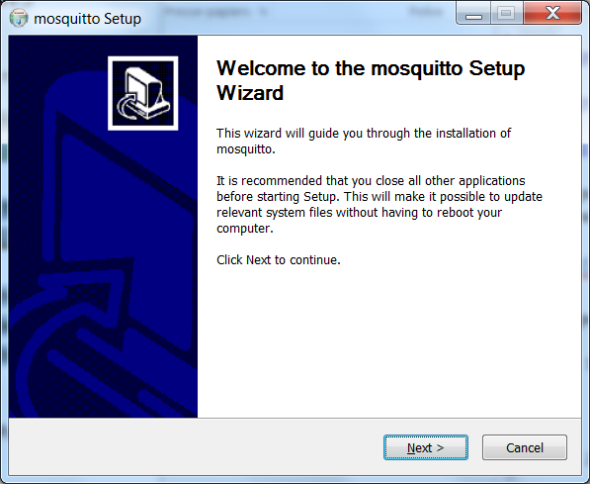

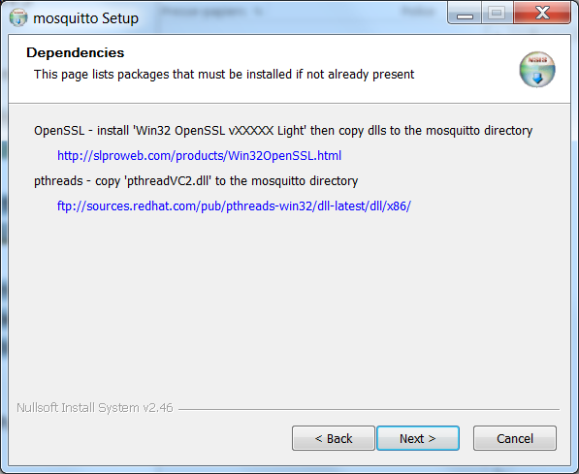

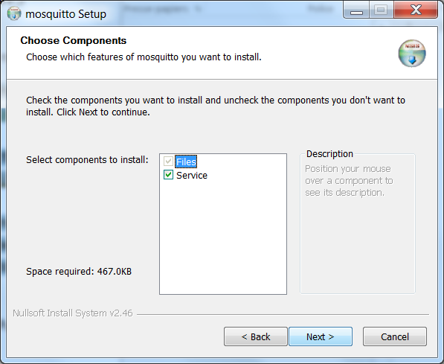

…

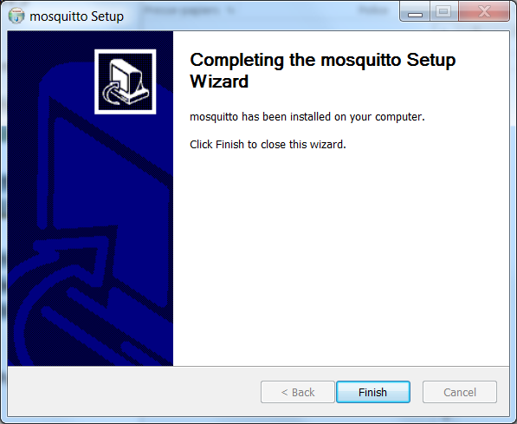

1. Install Mosquitto on Windows by following the steps specified in <https://sivatechworld.wordpress.com/2015/06/11/step-by-step-installing-and-configuring-mosquitto-with-windows-7/>

http://slproweb.com/products/Win32OpenSSL.html

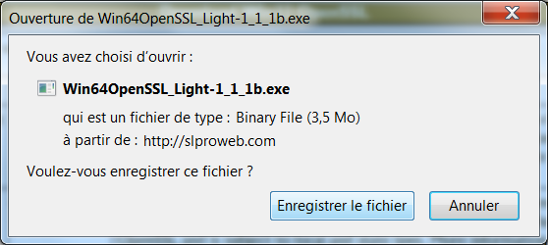

Suis les consignes pour récupérer les dll



Au lieu de Required DLLs: libeay32.dll ssleay32.dll (Look for these files in the OpenSSL-Win32 or OpenSSL-Win32\Bin folder)

Sur PC-LS2N installe la version 64bits (mosquitto + openssl) car échec

pthreadVC2.dll depuis ftp redhat

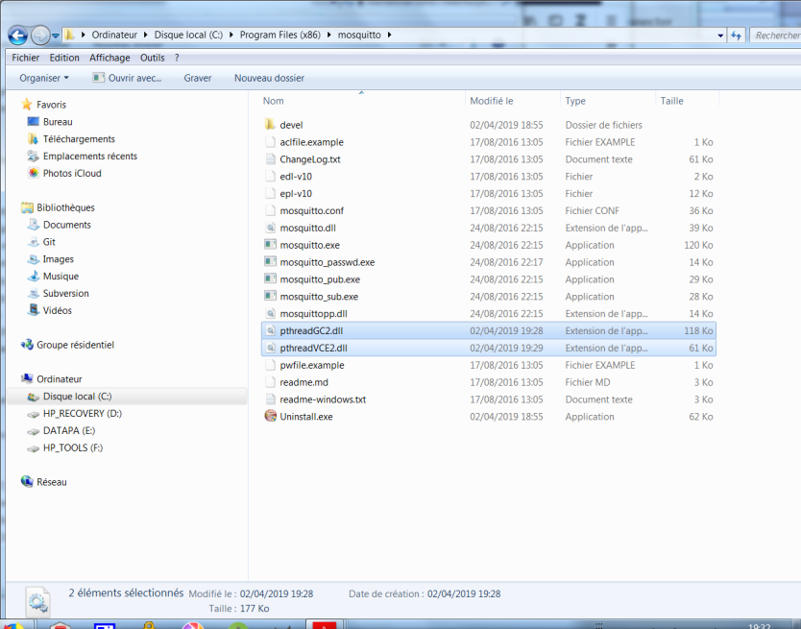

Réinstalle mosquito

Démarre le service

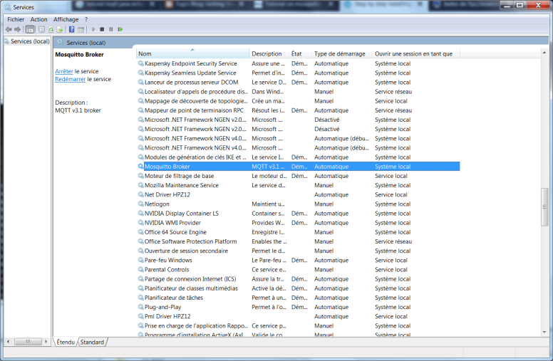

use the command netstat -an from the command prompt (cmd.exe)

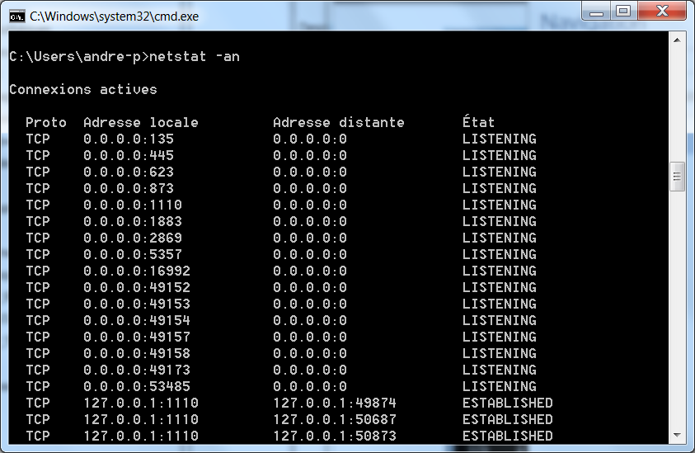

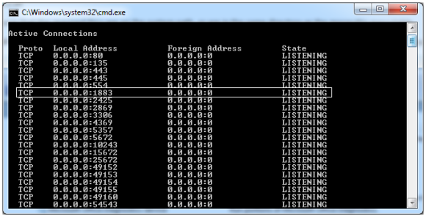

1. To start the Mosquitto service, open up Windows command line by clicking “Start” on the Taskbar, typing in “cmd” and pressing Enter. Navigate to where you installed Mosquitto. By default it will be located in “C:\Program Files (x86)\mosquitto” as shown on the picture below.

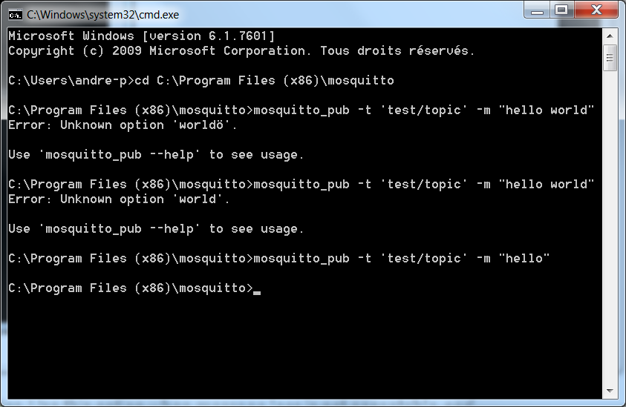

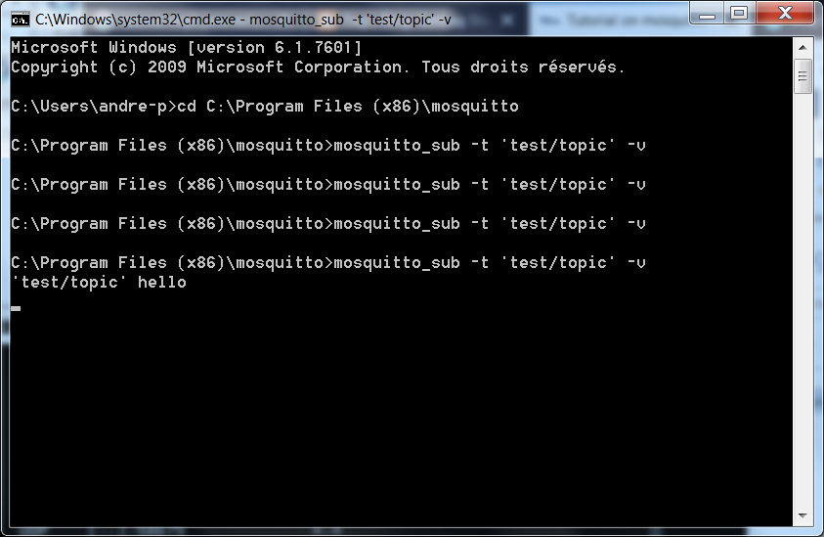

La suite ici

<http://tugdualgrall.blogspot.com/2017/01/getting-started-with-mqtt-and-java.html>

git clone https://github.com/tgrall/mqtt-sample-java.git

Eclipse / Oxygen

New project from source

mvn clean package

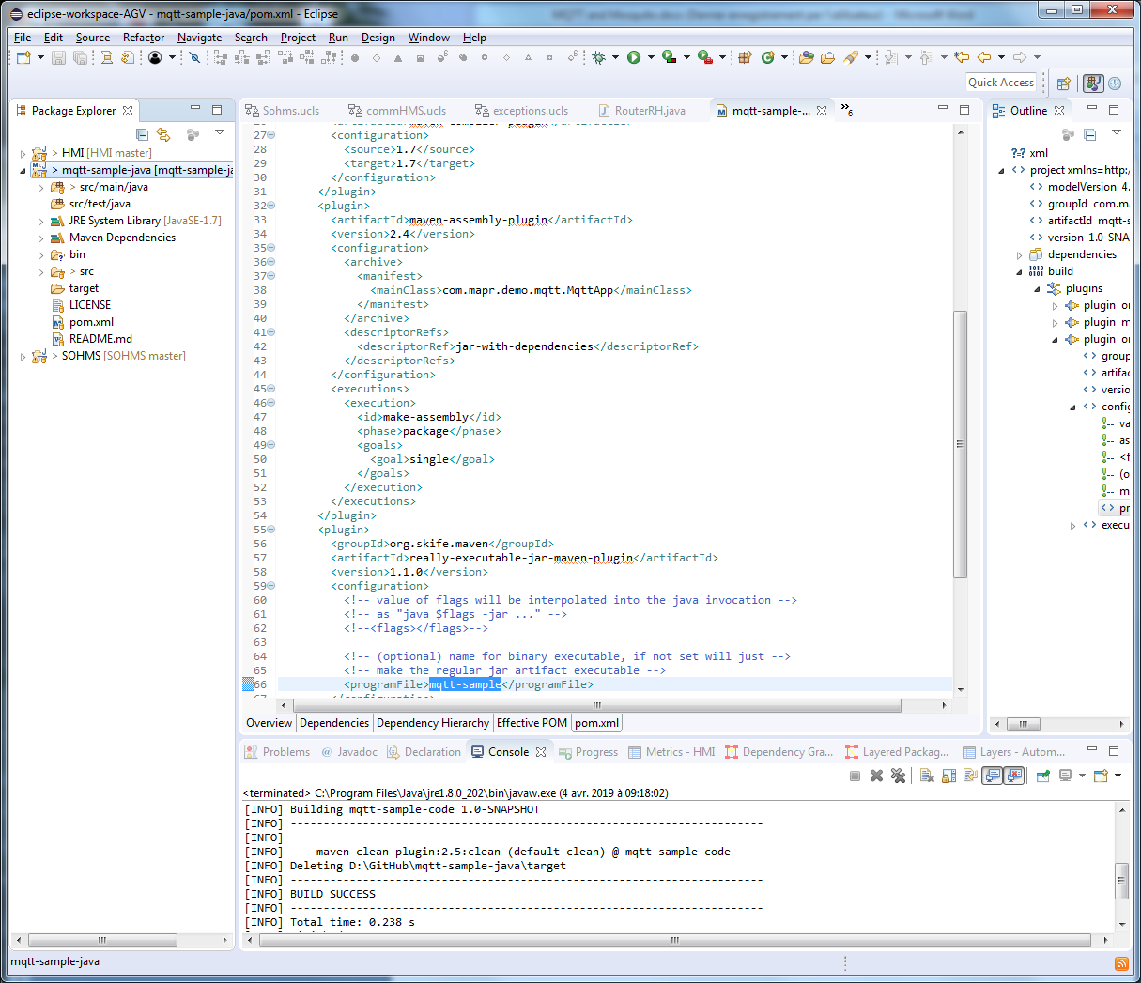

(Re)intalle JDK

<https://matsim.org/docs/devguide/eclipse/jdk>

problem :

[ERROR] Failed to execute goal org.skife.maven:really-executable-jar-maven-plugin:1.1.0:really-executable-jar (default) on project mqtt-sample-code: FAILURE! FAILURE!

<http://javaprotlib.sourceforge.net/packages/io/howtofixhadoop.html>

C:\Program Files (x86)\CVSNT\;C:\Users\andre-p\AppData\Local\GitHubDesktop\bin